Mysql

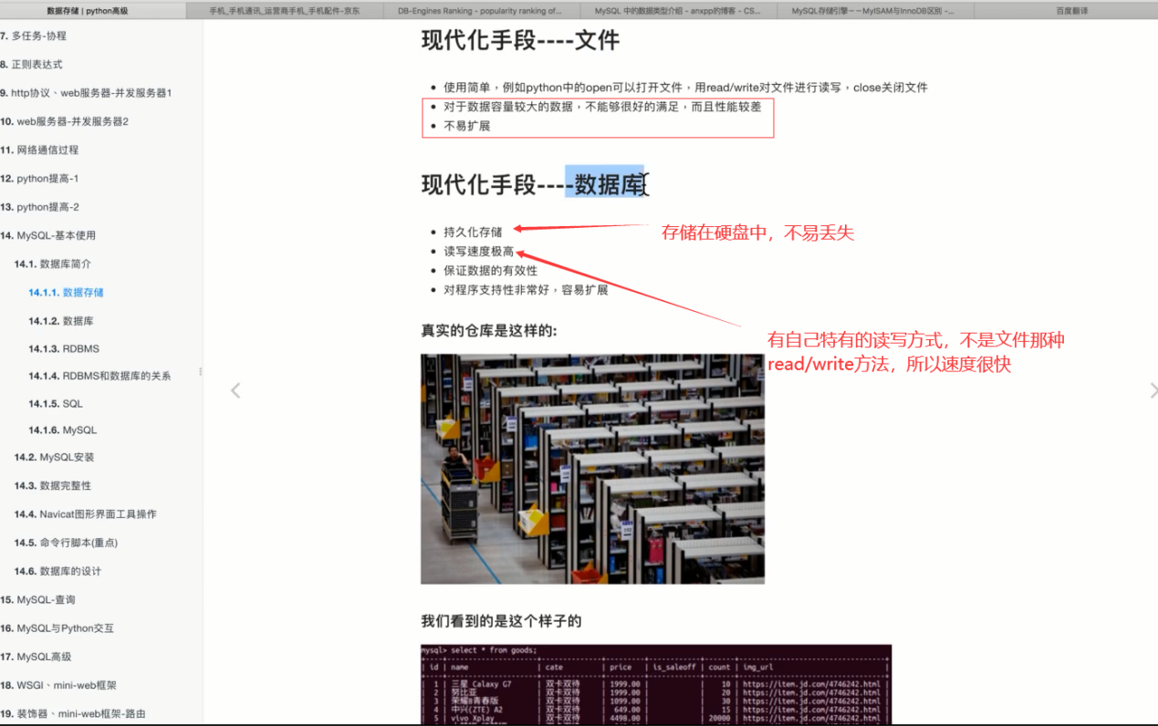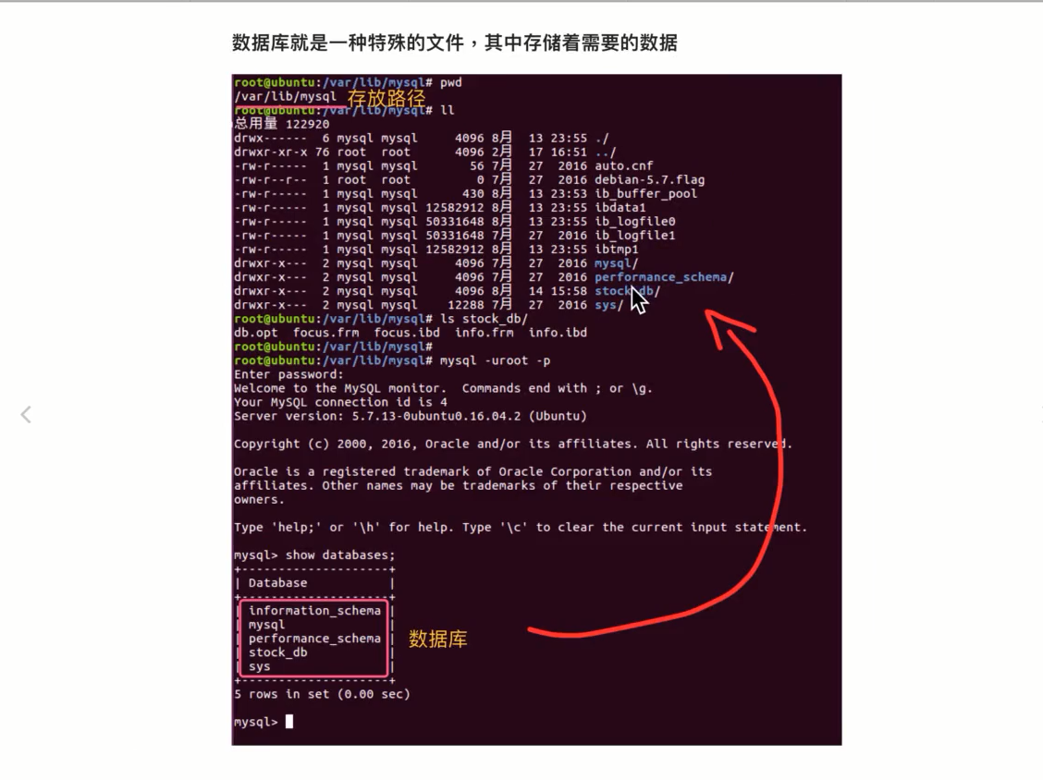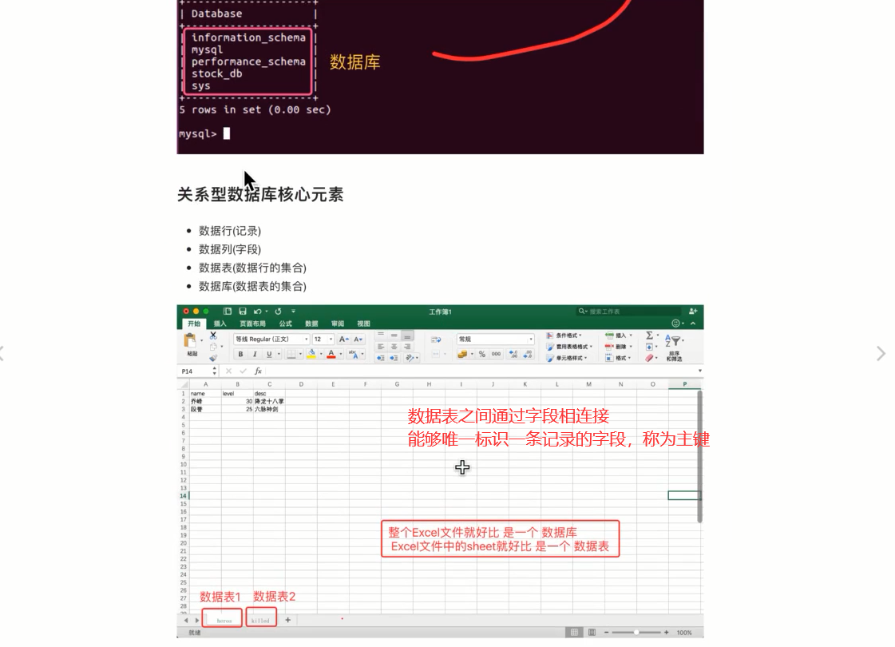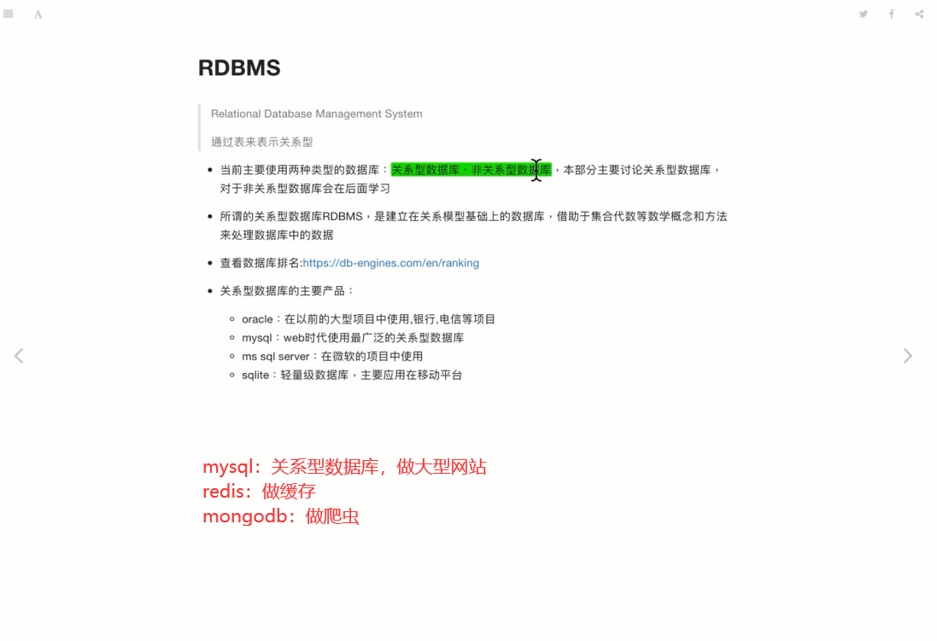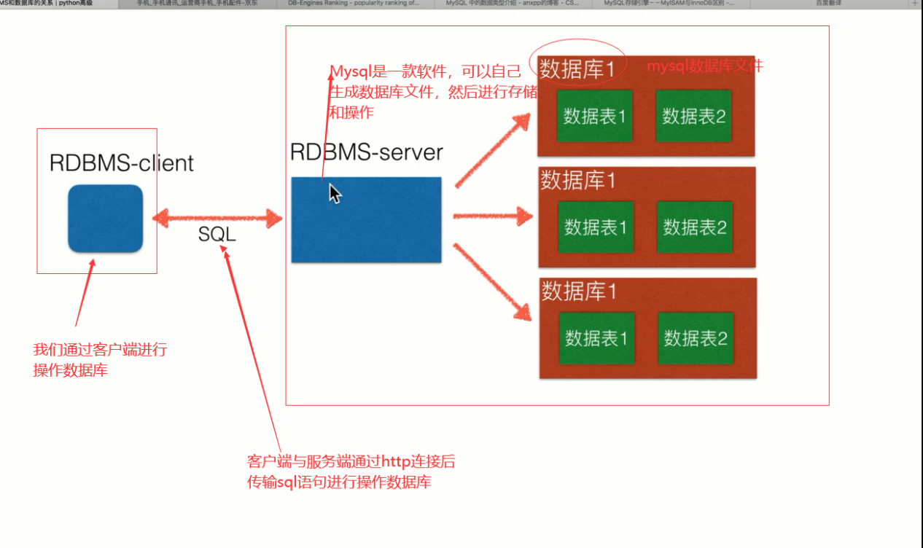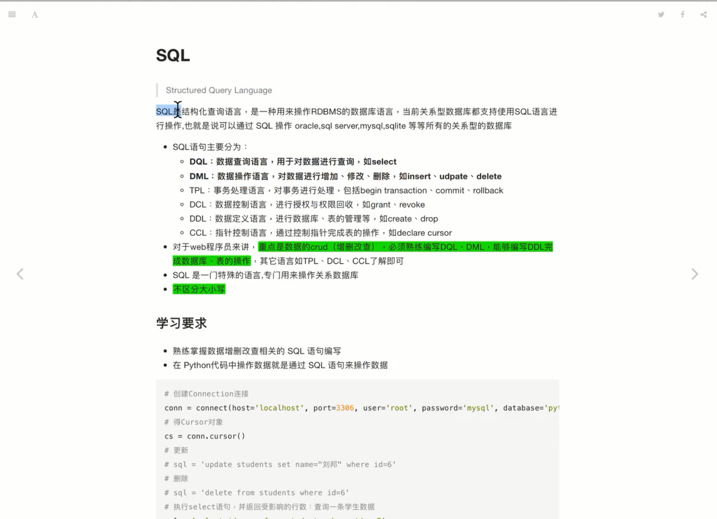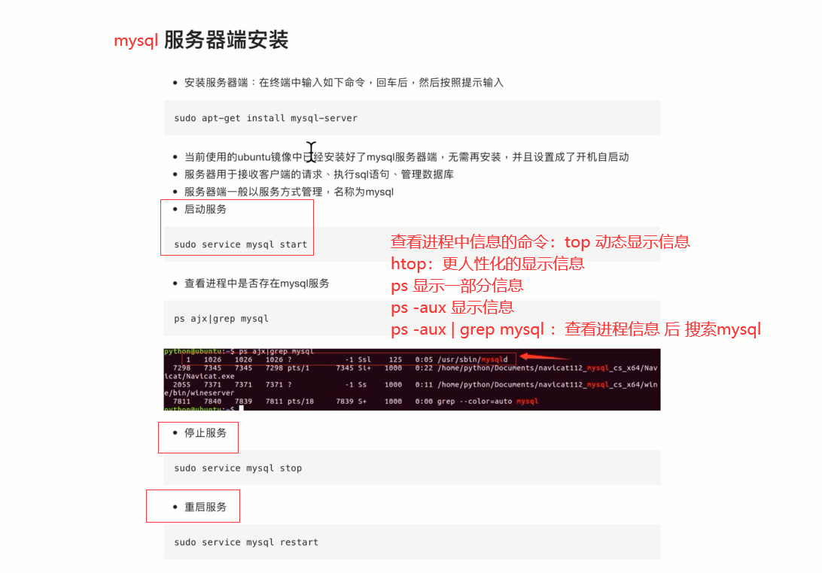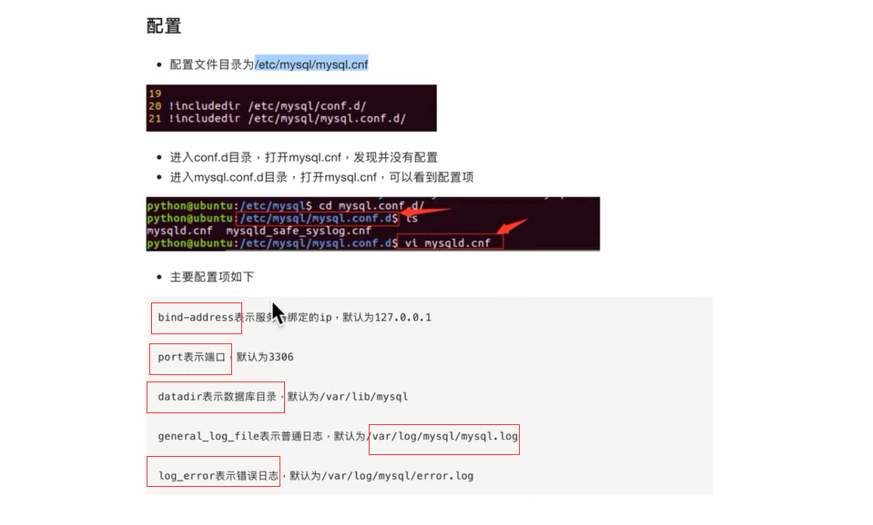

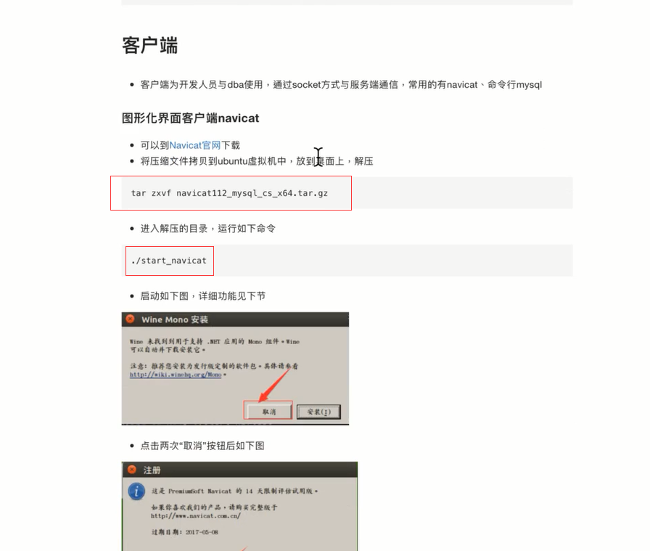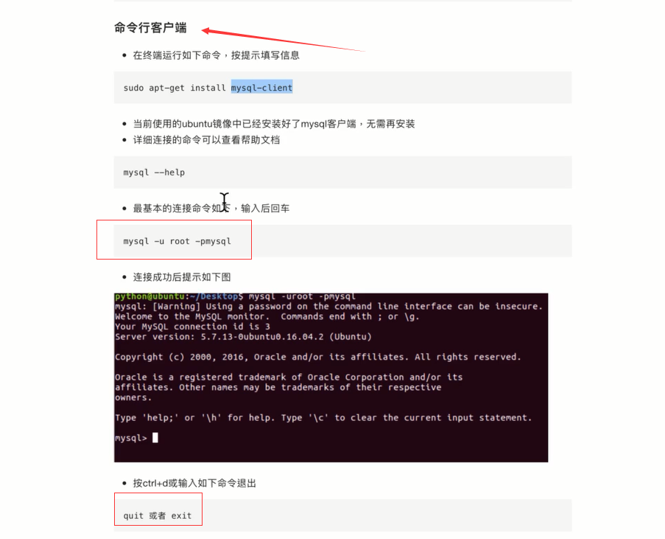

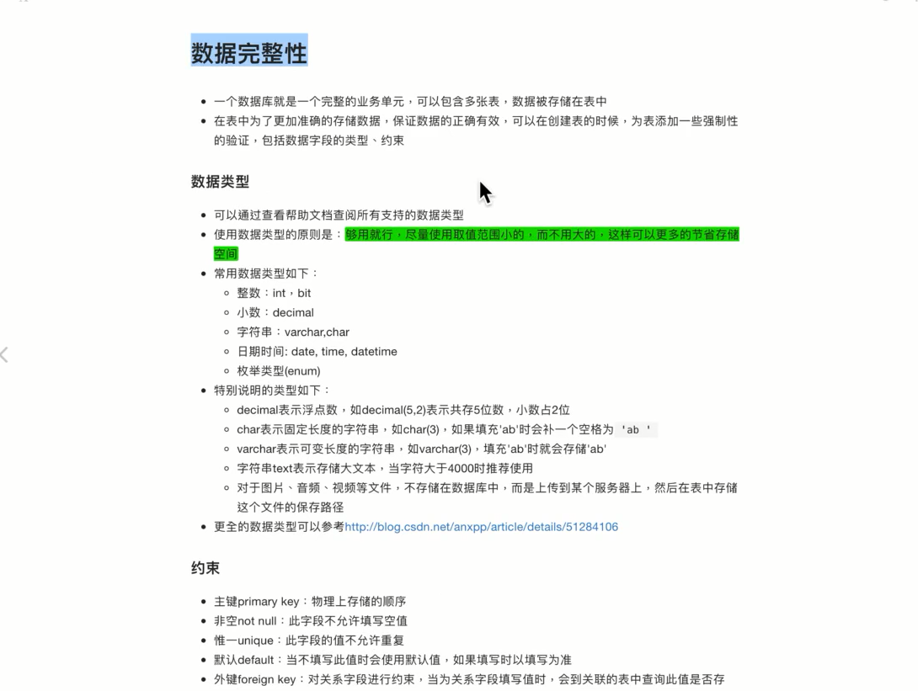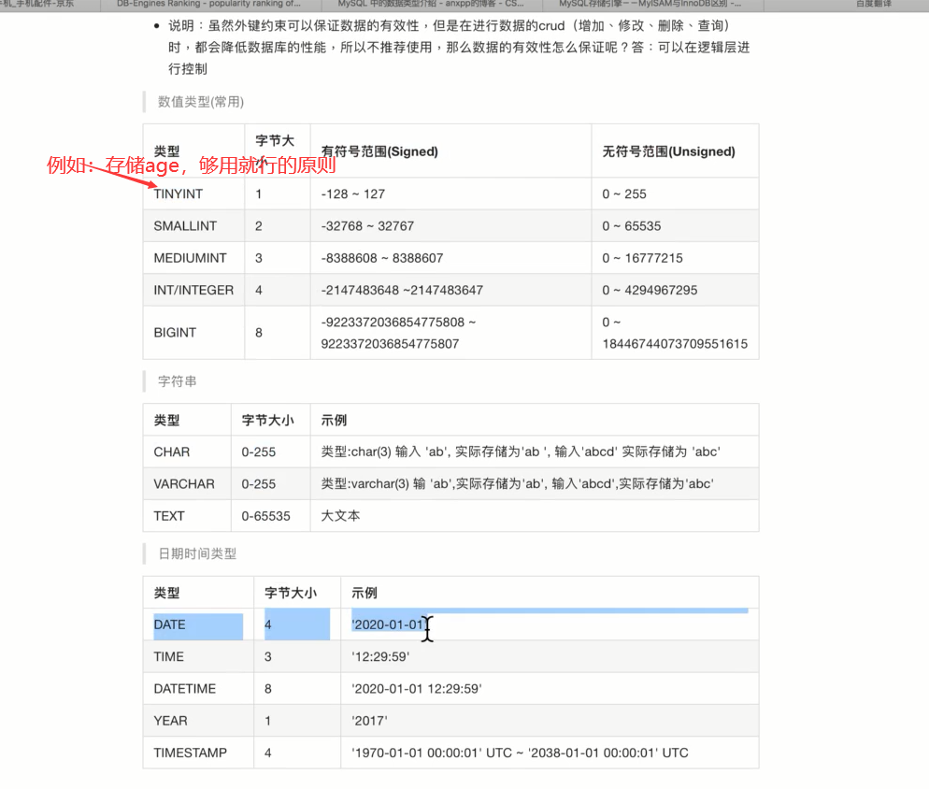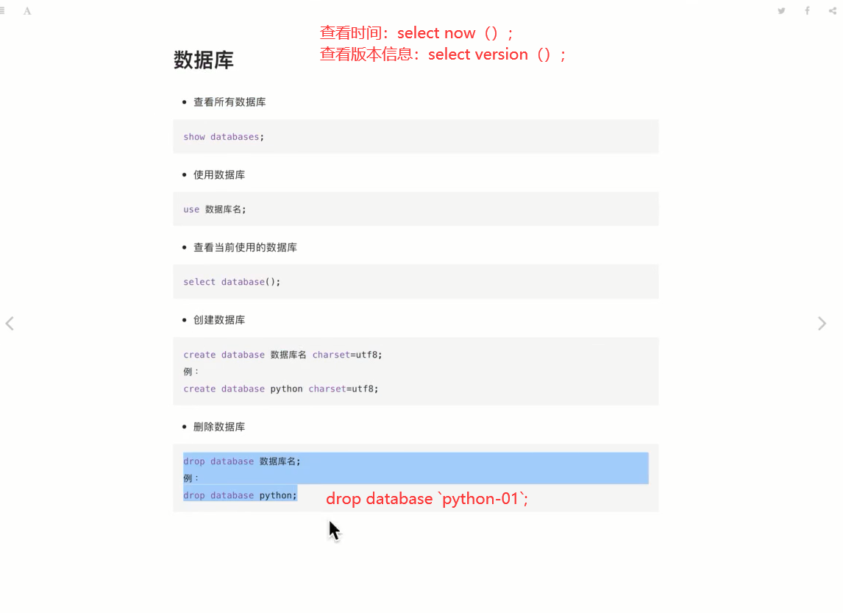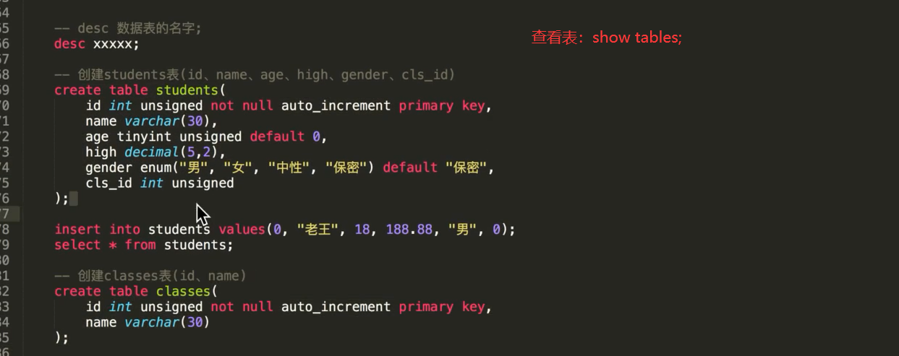

Desc 表名：查看表结构

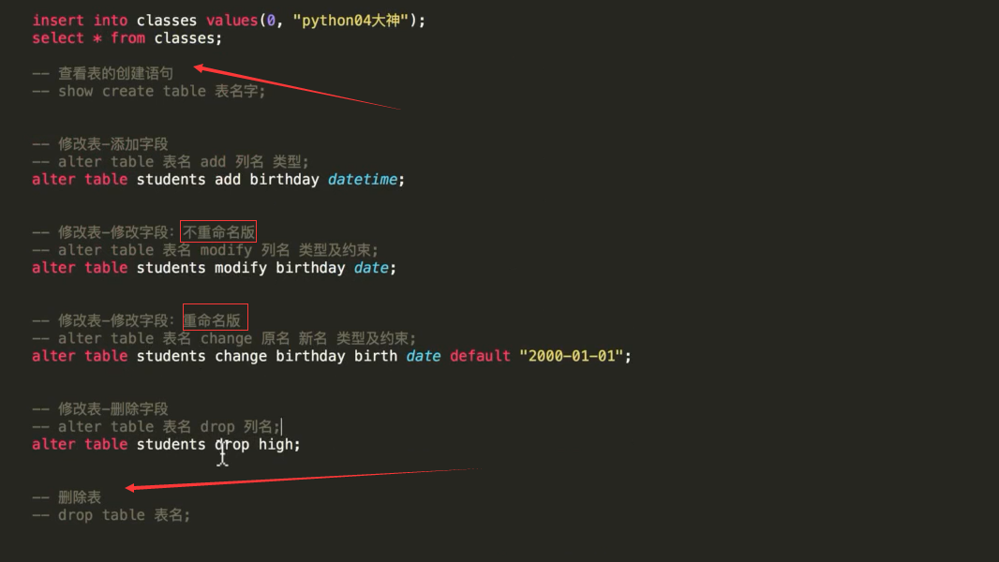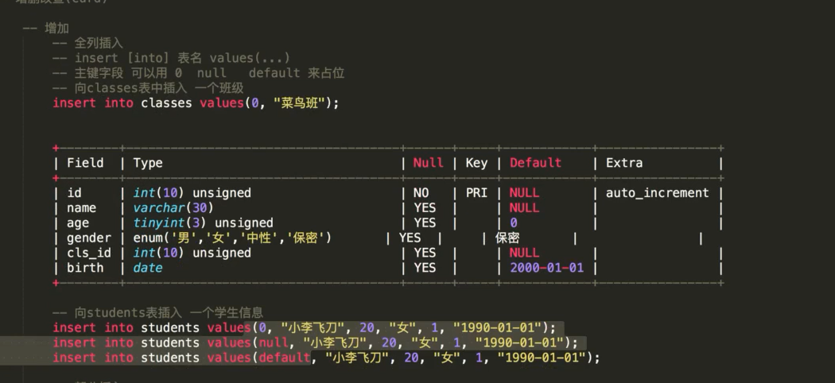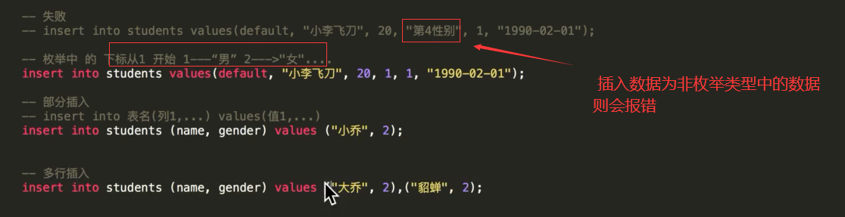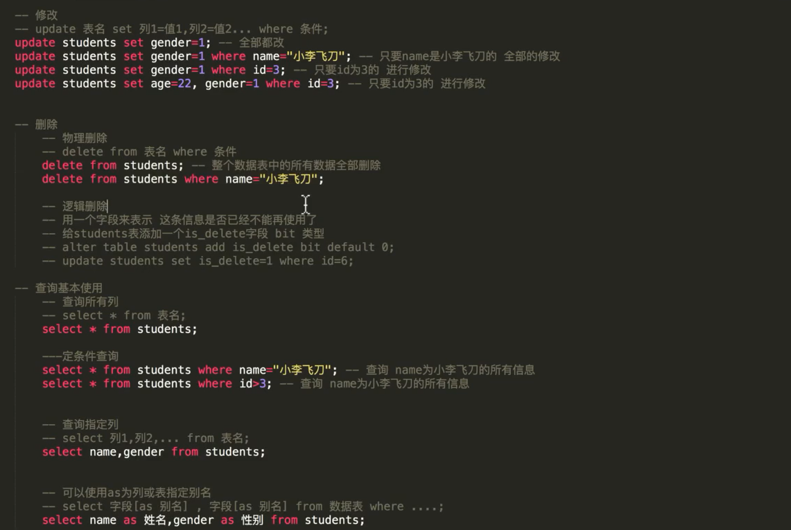

准备数据：创建两个数据表并插入数据

create table students(

id int unsigned not null primary key auto_increment,

name varchar(30),

height decimal(5,2),

gender enum('男','女','中性','保密') default '保密',

age tinyint unsigned,

cls_id int unsigned

);

insert into students values(0,'yolo',172.52,'男',21,56);

create table classes(

id int unsigned not null primary key auto_increment,

name varchar(30)

);

insert into classes values(0,'python大神');

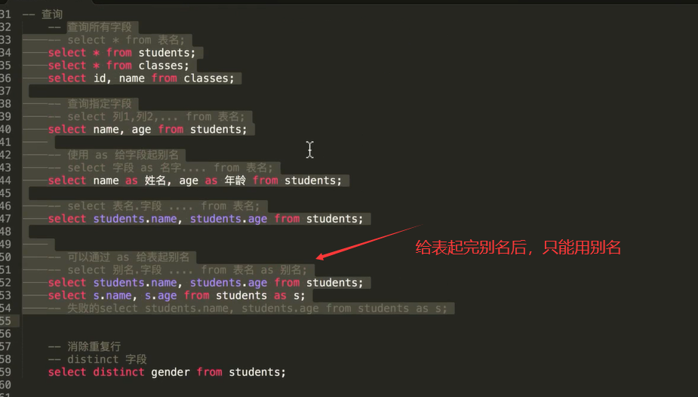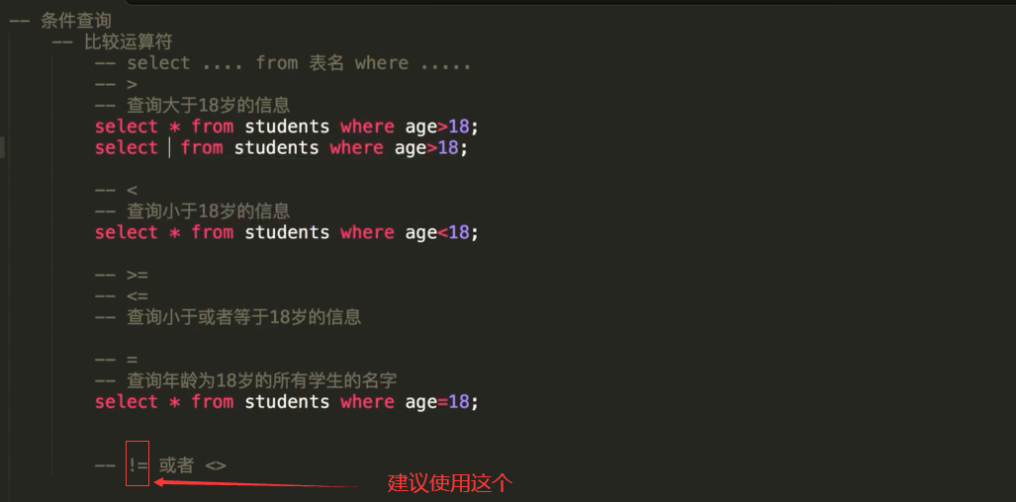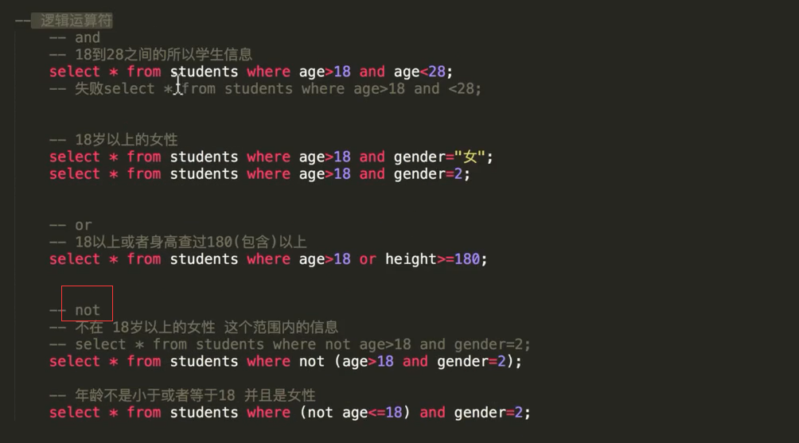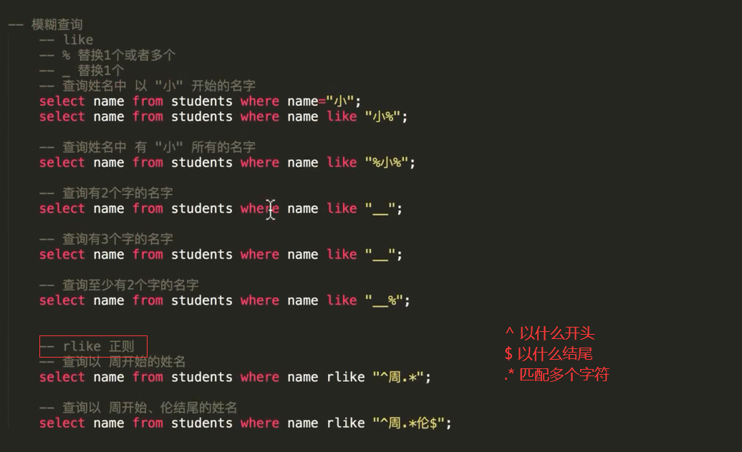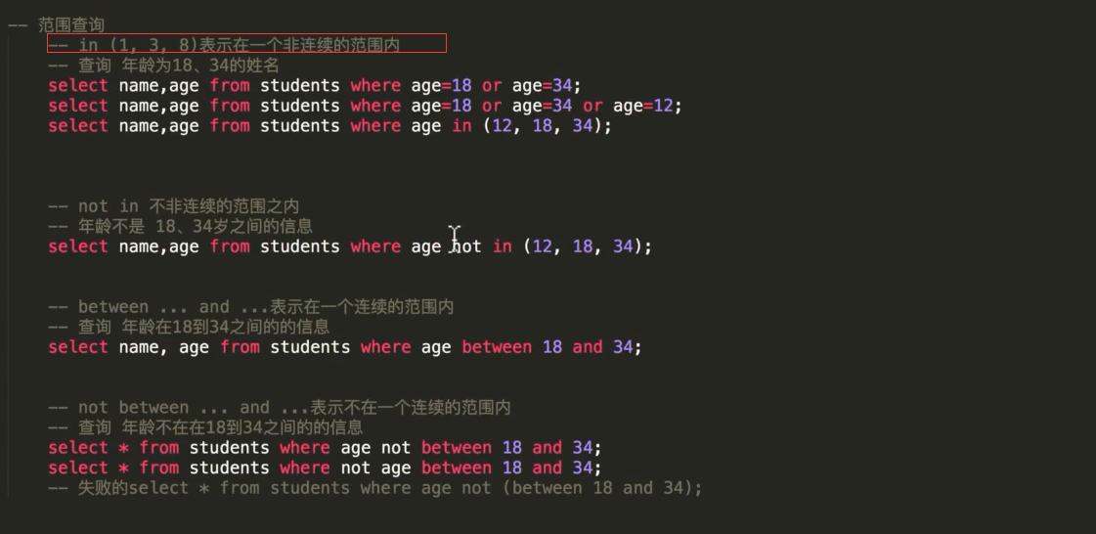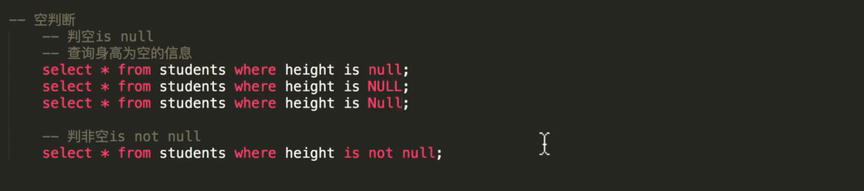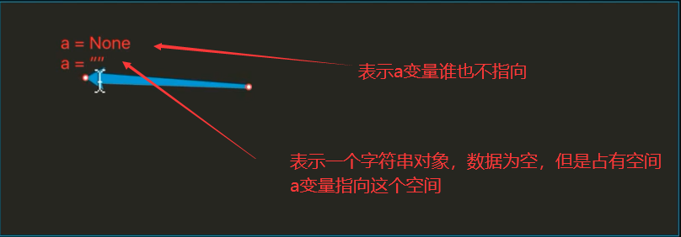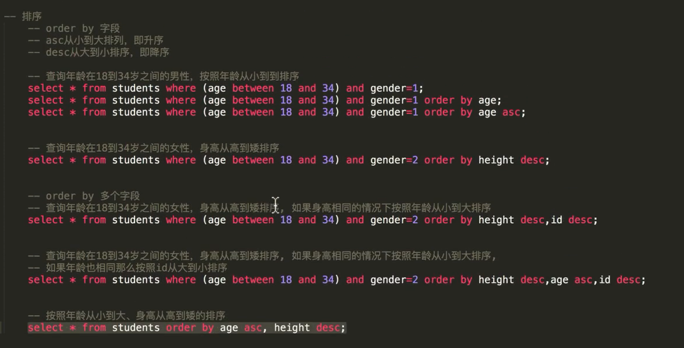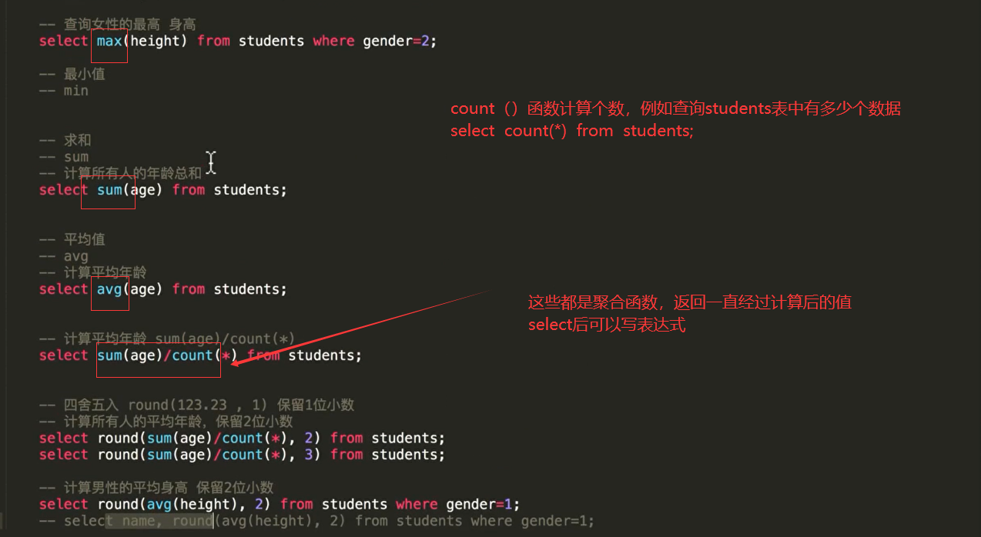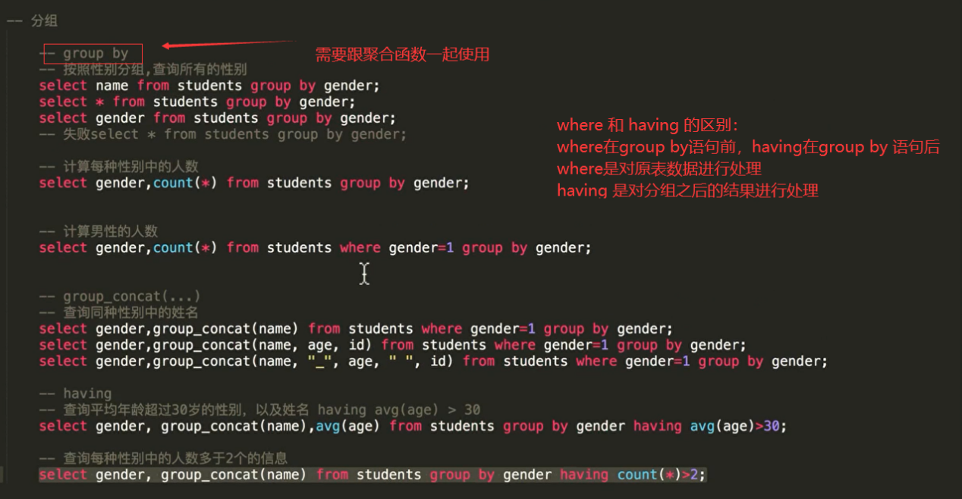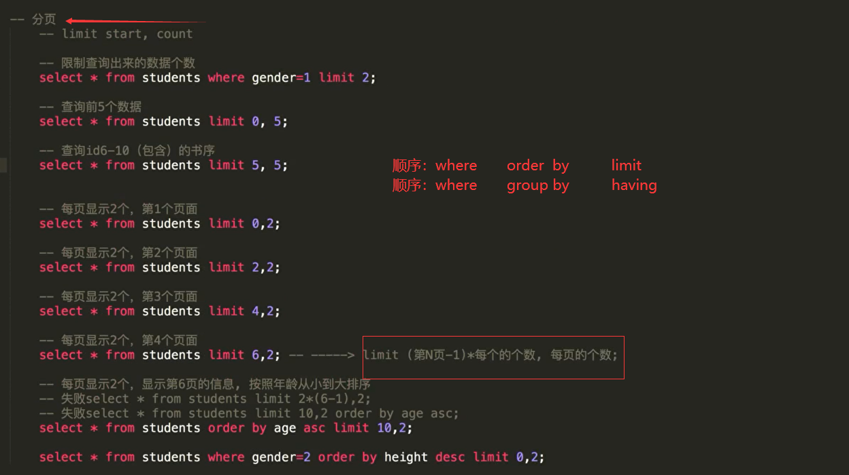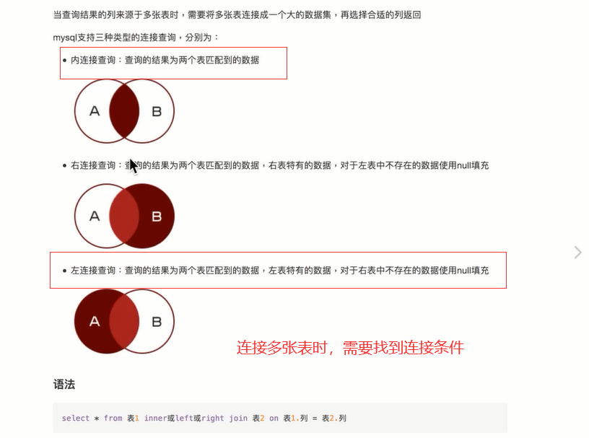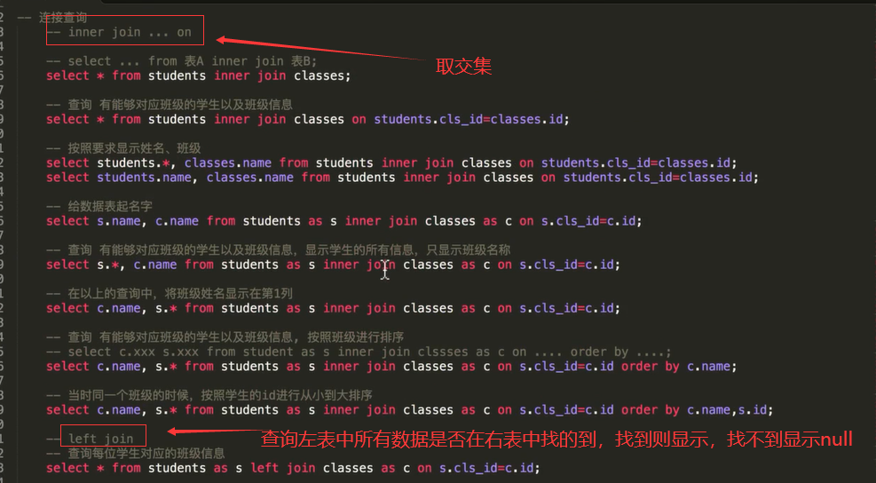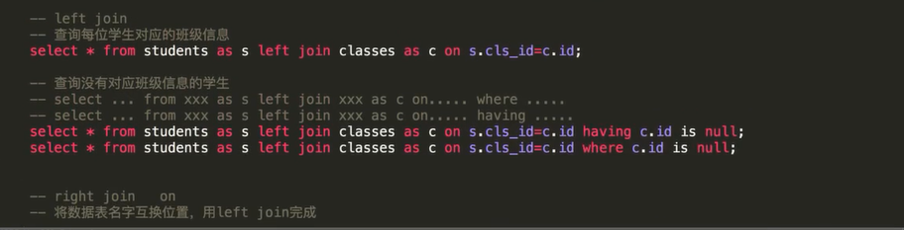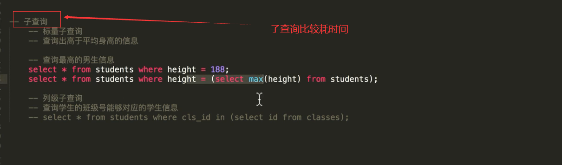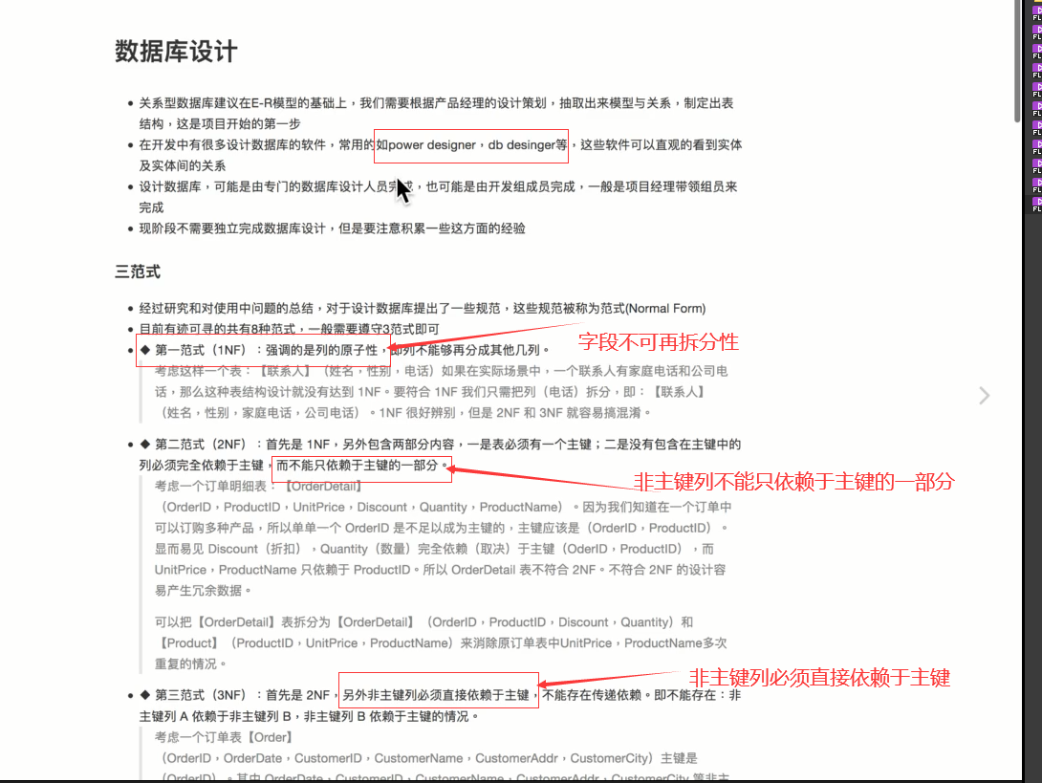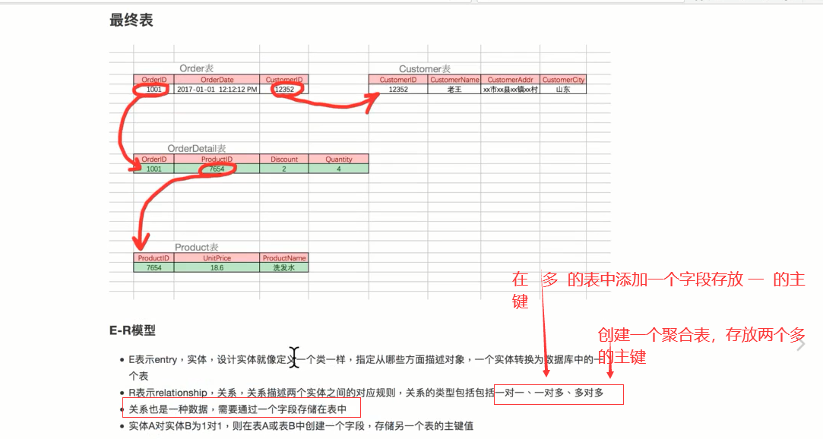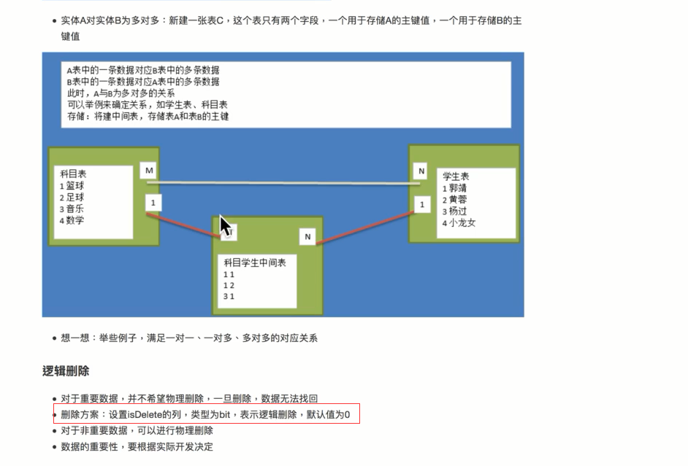

强化：

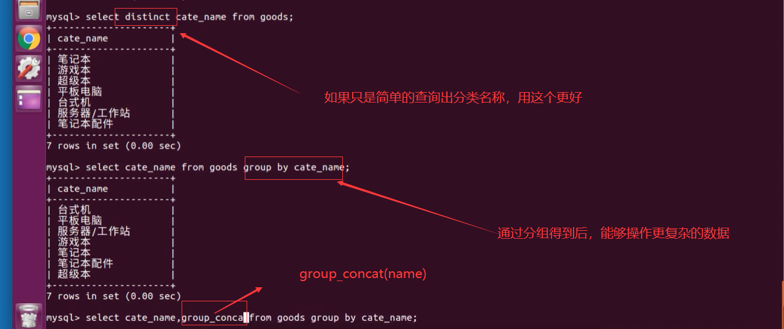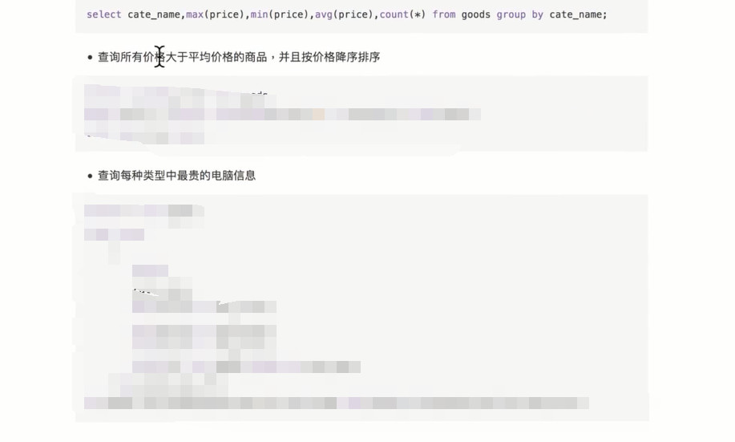

答案:1.select name,price from goods where price > (select avg(price) from goods ) order by price desc;

1. select *from (select cate_name,max(price) as max_price from goods group by cate_name ) left join goods as g on g_new.cate_name=g.cate_name and g_new.max_price=g.price order by g_new.cate_name;

拆表的步骤：

1. 创建另外一个表
2. 同步表数据
3. 修改原表的字段名和类型
4. 创建外键约束

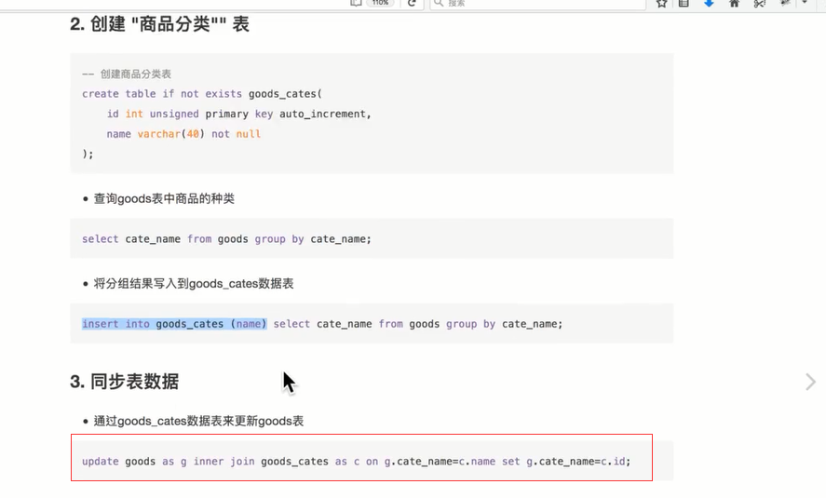

alter table goods change cate_name cate_id int unsigned;

alter table goods add foreign key(cate_id) references good_cates(id);

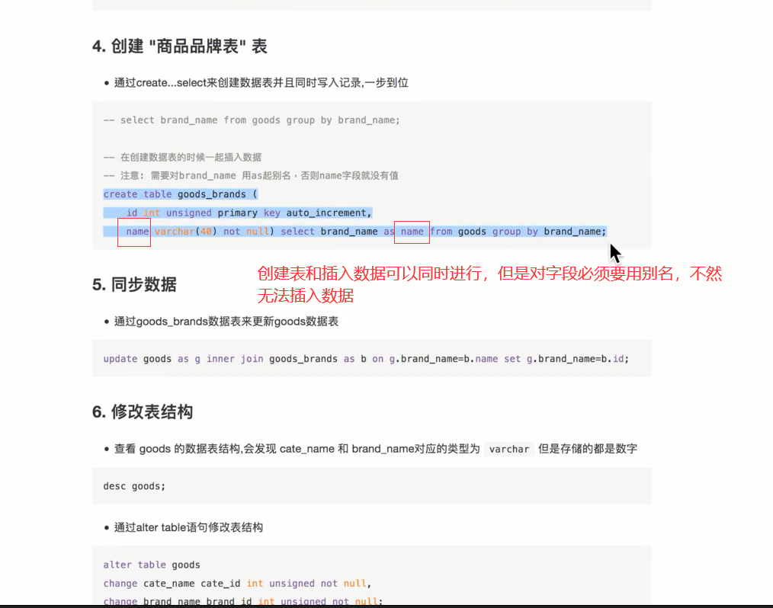

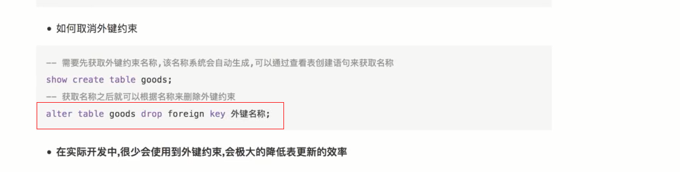

Pymysql库操作数据库步骤

1. 导入pymyql库，如果要用到多个库，使用import这个方式
2. 进行connect连接，获得connect对象
3. 通过connect对象的cursor方法，获得游标对象
4. 通过游标对象的execute方法执行sql语句，得到查询结果
5. 取出游标对象中的数据使用游标对象的三种方法，fetchall,fetchmany,fetchone
6. 关闭游标对象
7. 关闭connect对象

